Phonics | Literacy/Handwriting | Maths- One more | Topic- Easter
www.phonicsplay.co.uk  Flash Cards- How many sounds can you recall in 1 minute?  Phase 3- Flash Cards (Sets 1-10)  Pick A Picture- practise reading words with Phase 3 sounds.  How many words can you think of with the ‘sh’ sound? Can you write a list? | Practise letter formation for Tricky Word: we  Can you write a sentence using the word ‘we’?  Have you remembered to use: Capital Letter; finger spaces; spelt tricky words correctly; full stop; and be able to read it back. | Count Easter objects using numbers up to 20.  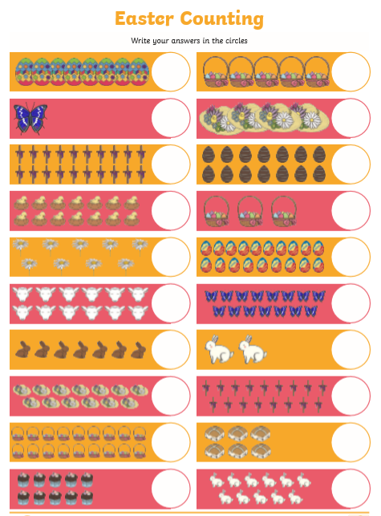  Practice counting in 2s and 10s. | Find out about why people celebrate Easter.
www.phonicsplay.co.uk  Flash Cards- How many sounds can you recall in 1 minute?  (Sets 1-10)  Train Your Brain- Practise reading Phase 2 & 3 Tricky Words.  Tricky Trucks- Can you speed read phase 2 & 3 tricky words? | Practise Number Formation 3-5. | Make a set of number cards 0-10.  Turn them face down. Choose a number card- Which number is one more than your number?  Can you record a number sentence to show your calculation?  5 + 1 = ?  Can you extend to using numbers to 20?  Can you find two or three more by counting on from your number?  Practice counting in 2s and 10s. | Make a poster about the different ways people celebrate Easter.  Can you write captions on your poster?  You could do this on PurpleMash!
www.phonicsplay.co.uk  Flash Cards- How many sounds can you recall in 1 minute?  (Sets 1-10)  Buried Treasure- Can you read and sort words. Practise with Phase 2 and Phase 3 words up to +ar).  How many words can you think of with the ‘ch’ sound? Can you write a list? | Practise letter formation for Tricky Word: be  Can you write a sentence using the word ‘be’?  Have you remembered to use: Capital Letter; finger spaces; spelt tricky words correctly; full stop; and be able to read it back. | Play I say we say…  The grown up says a number 0-10. The child responds by saying the number which is one more at speed.  Can you make the game harder- extend to numbers to 20 or even beyong.  Change the rules- e.g. say the number 2 more.  Practice counting in 2s and 10s. | Decorate Easter Eggs  Log into PurpleMash and use the paint tools to create your own design. Miss Blagden has set this as a ‘2do’ activity.  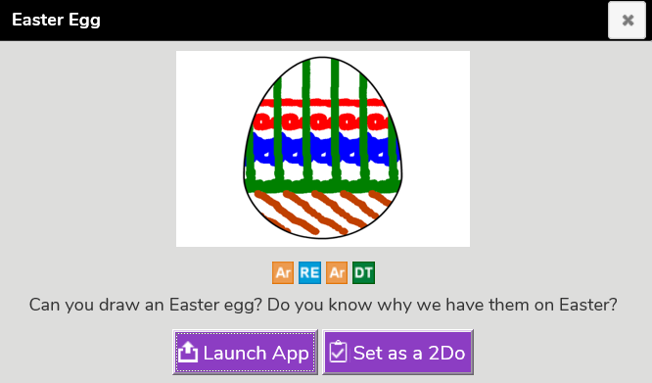
www.phonicsplay.co.uk  Flash Cards- How many sounds can you recall in 1 minute?  (Sets 1-10)  Train Your Brain- Practise reading Phase 2 & 3 Tricky Words.  Tricky Trucks- Can you speed read phase 2 & 3 tricky words? | Practise Number Formation 6-8. | 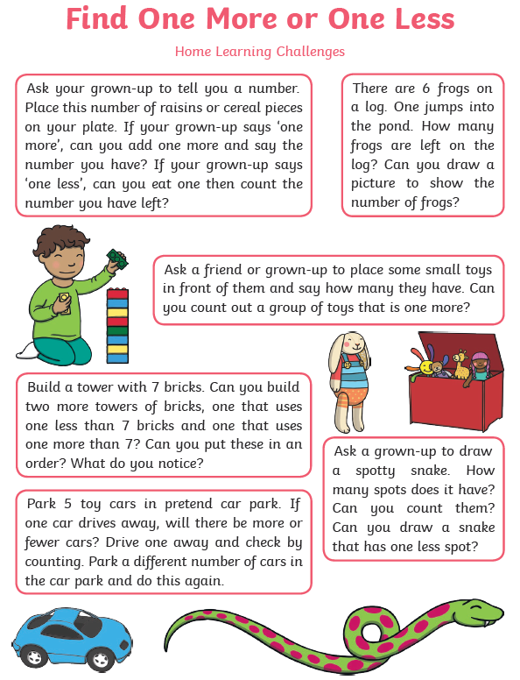 | Easter Baking  People often celebrate Easter by eating chocolate or making buns. Try making a sweet treat to share with your family.  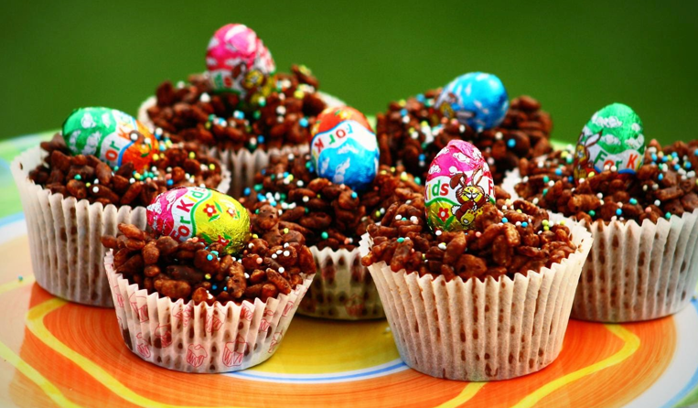  We would love to see a photo of any treats that you make.
www.phonicsplay.co.uk  Flash Cards- How many sounds can you recall in 1 minute?  (Sets 1-10)  Space Race- help build the rocket by spelling the Phase 3 words.  How many words can you think of with the ‘th’ sound? Can you write a list? | Practise letter formation for Tricky Word: was  Can you write a sentence using the word ‘was’’?  Have you remembered to use: Capital Letter; finger spaces; spelt tricky words correctly; full stop; and be able to read it back. | Practice counting in 2s and 10s.  Use objects to help you solve simple number sentences:  4 + 1 = ?  6+1 = ?  14 + 1 = ?  17 + 1 = ?  Lets make them harder…  8 + 2 =  16 + 2 =  Even harder…  8 + ? = 11  Can you make your own addition number sentences up? | Easter Card  Make a happy Easter card to give to a member of your family.  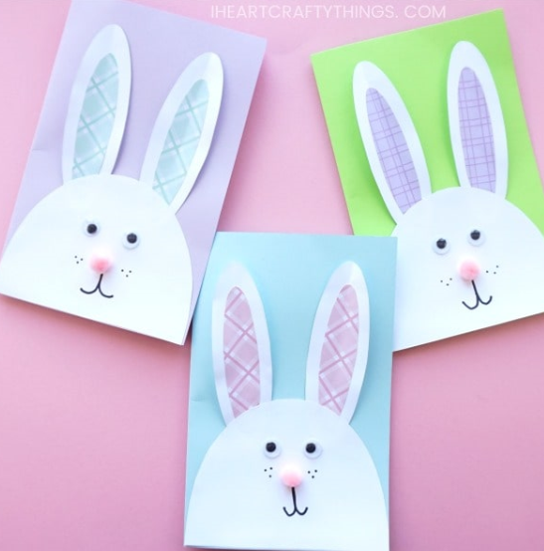  Remember to spell tricky word ‘to’ correctly.

