Spellings | Literacy | Maths | Topic
Play an assignment on Spelling Shed  Spellings to practice using speed spell or pyramid spelling  Nicer  Writer  Baker | Can you create a diary and write a little bit about what you have been doing each day. | Time  Topmarks maths games – time  Using a clock or a watch, can you tell the time to o’clock, half past and quarter past or to?  Practice  3 times table | Science – Plants  When you are in your garden or out for a walk can you look for spring flowers?  Can you see the new buds coming on the trees?  Can you draw a picture of plants and flowers?
Play an assignment on Spelling Shed  Spellings to practice using speed spell or pyramid spelling  Hoped  Loved | Can you practice your handwriting by writing our weekly spellings in your neatest joined handwriting? | Time  Practice telling the time several times during the day.  Practice  3 times table | Science – Plants  Can you measure your sunflower plant that you took home from school as it grows and record it each week?
Play an assignment on Spelling Shed  Spellings to practice using speed spell or pyramid spelling  Largest  Closest | Can you write a sentence for each of our weekly spellings? | Time  Practice telling the time several times during the day.  In your diary can you write at what times you did different things? | Science – Plants  Can you make a list or draw a picture of all the plants that you eat? Eg. Fruits, salad and vegetables.
Play an assignment on Spelling Shed  Spellings to practice using speed spell or pyramid spelling  Looser  Safer  Simpler | Look at a plant or flower in your garden, your house or out of your window.  How many different adjectives (describing words) can you think of to describe the plant or flower? You could even use an online thesaurus to use really interesting words. | Challenge  Time yourself to see how many times you can do activities in 1 minute.  Eg.  Run around the garden  Write your name  Throw and catch a ball  Practice  3 times table | Science – Plants  Thinking about the plants that you eat can you name which part of the plant are you eating?  Eg.  Grapes are the fruit  Carrots are the roots  Lettuce is the leaves
Can you do a spelling test with a grown of this week’s spellings?  Nicer  Writer  Baker  Largest  Closest  Looser  Safer  Simpler  Hoped  Loved | When you are eating fruit, salad or vegetables can you describe what they taste like using different adjectives (describing words)? | Time  Practice telling the time several times during the day.  In your diary can you write at what times you did different things?  Practice  3 times table | Art  Fruits and vegetables  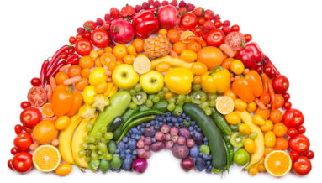  Can you think about the colours of different fruits and vegetables and create a colour grouped picture? Maybe in the shape of a rainbow.

