Phonics | Literacy/Handwriting | Maths- 1 Less/Take Away | Topic- Frogs
Check out the DfE’s new daily online phonics lessons for parents:  https://www.youtube.com/channel/UCP_FbjYUP_UtldV2K_-niWw/  Remember your child will also benefit from regular practise of a range of Phase 2 and Phase 3 games on Phonics Play website:  Remember to practise segmenting and blending words when reading and spelling!  Regina says remember to read a book everyday!  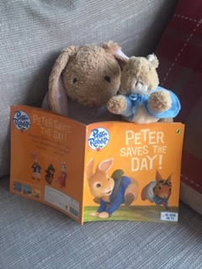 | Practise writing your full name.  Can you write it from memory?  How many times can you write your name in one minute? Are all the letters correctly formed? Can you beat your score if you try again? | Practise counting up and back from 0-20.  You could make it active counting by jumping, clapping, hopping too. | This week Regina Rabbit will be reading a book all about Frogs. She has discovered some tadpoles in Mrs Bradley’s pond and wants to know where they have come from and what will happen to them as they grow.  Can you help Regina by completing these home learning challenges?  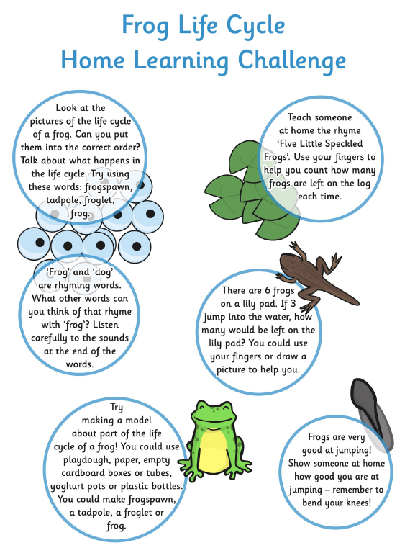
What number comes before….?

The adult will say a number between 1-20- Can you think what number comes before?

Can you record a number sentence to show your thinking?

E.g. 4 – 1 = 3

Practise letter formation:

https://www.doorwayonline.org.uk/activities/letterformation/

Remember to click free draw and you can either practise a random selection or your grown up might choose letters that they think you need extra practise with.
Play Simple Take Away 3-7 on Topmarks website to practise subtraction skills.
https://www.topmarks.co.uk/Flash.aspx?f=TakeAway
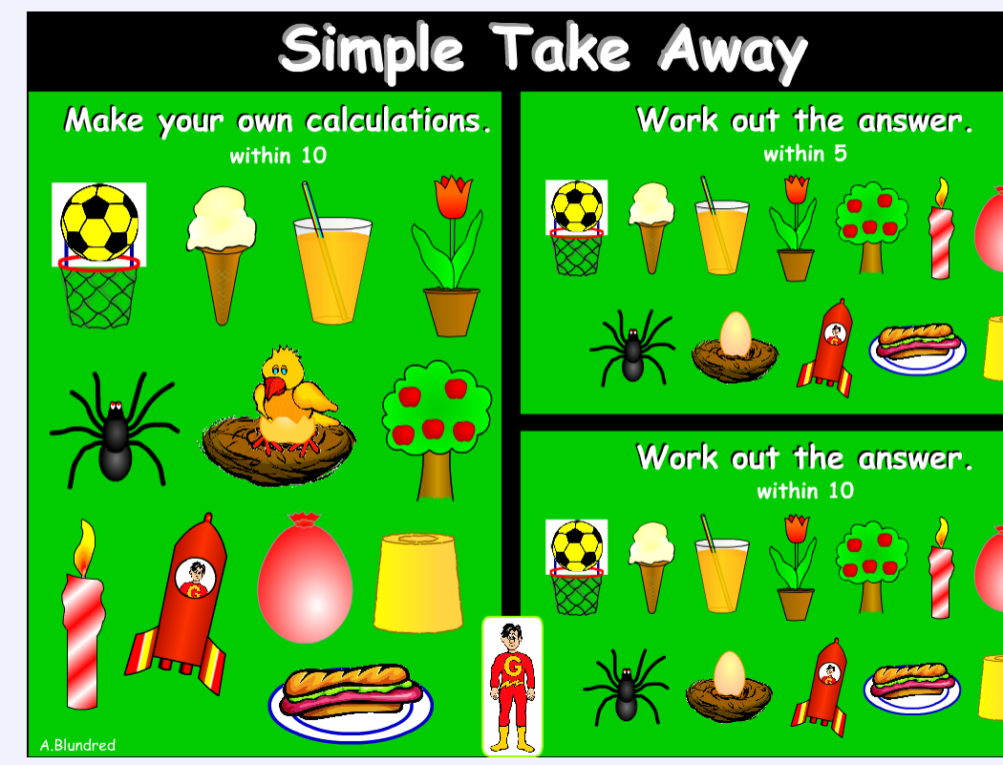
Develop your fine motor skills to help improve your letter formation.
Can you thread beads? Learn to fasten buttons or laces? Can you join small pieces of construction?
 | Practise number formation:  https://www.doorwayonline.org.uk/activities/letterformation/  Remember to click free draw and you can either practise a random selection or your grown up might choose numbers that they think you need extra practise with. | Can you calaculate which numbers come before and after the given number?  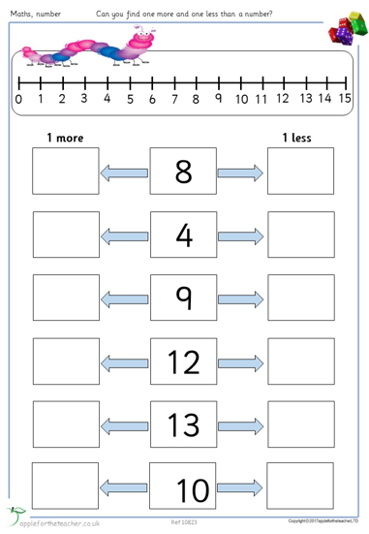 | Don’t forget to log on to Purple Mash to check out your 2Dos and remember you can send your photos and videos to FS2obs@astreacastle.org or post on the school’s Facebook page too.  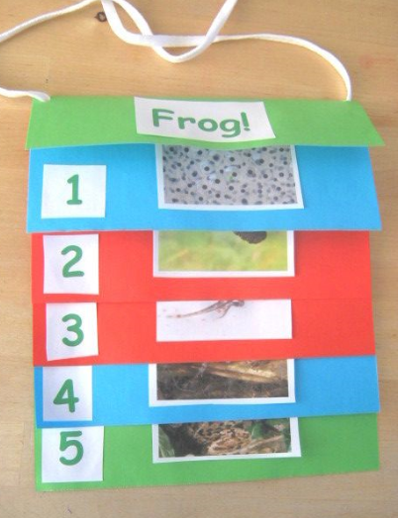  How creative can you be in the way your present the life cycle of a frog?  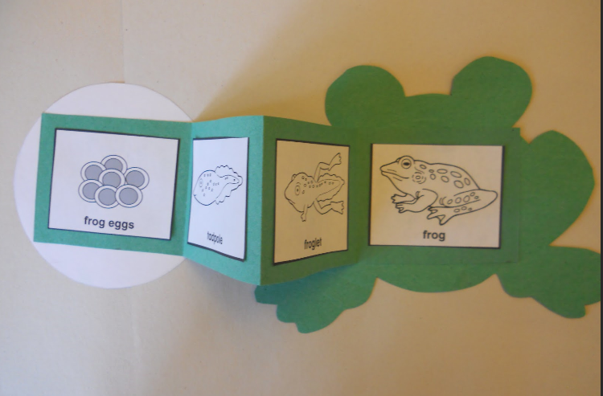
 | Practise scissor skills.  Draw a picture and cut it out or print out a copy of the scissor skills practise sheets.  Are you holding the scissors correctly? Are you using your other hand to hold the paper? | Make up problems involving tadpoles and frogs to help you develop your reasoning skills.  There a 10 tadpoles in the pond. One is eaten by a bird. How many tadpoles are left?  How do you know? Can you record a number sentence to show how you calculated the answer?

