Phonics | Handwriting/Tricky Words | Maths- Doubles | Topic- VE Day Celebrations
Check out the DfE’s new daily online phonics lessons for parents:  https://www.youtube.com/channel/UCP_FbjYUP_UtldV2K_-niWw/  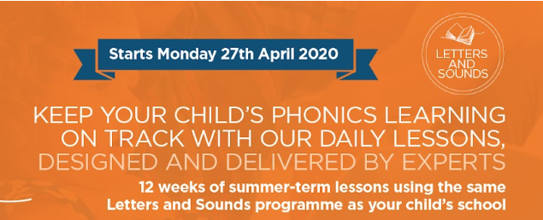  Remember your child will also benefit from regular practise of a range of Phase 2 and Phase 3 games on Phonics Play website:  Remember to practise segmenting and blending words when reading and spelling!  You might also find the KS1 Bitesize Phonics lessons and games useful.  Regina says remember to read a book every day!  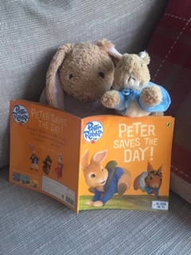  Mrs Mason has also set the challenge to read to read in an unusual place.  Where will you choose to read this week?  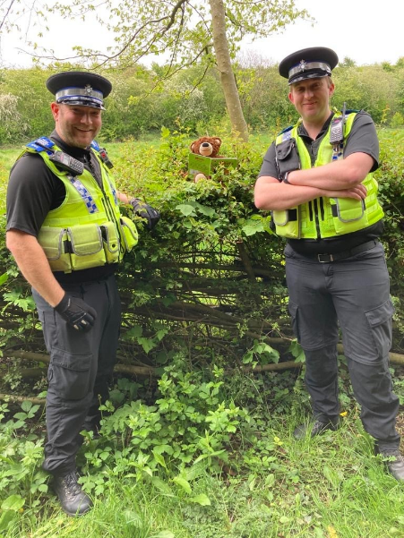  Boris found reading in a bush with two police officers a little unusual this week. Send your pictures to fs2obs@astreacastle.org | This week can you find different ways to practise spelling the Phase 3 tricky words:  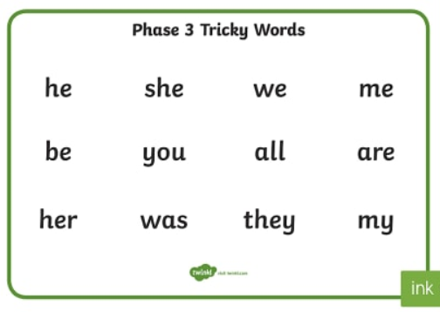  How many words can you write from memory?  We have uploaded a Phase 3 Tricky Word Booklet and Letter Formation sheets on the class webpage, which you might find useful. | Use household objects to practise finding double.  E.g. choose a number or roll a dice. Count out that many objects. Remind children that double means to add the same amount again. Count out another set. Combine both sets of objects to find the total.  Can you record number sentences to show your calculations?  4 + 4 = ?  Can you double numbers up to 10? | 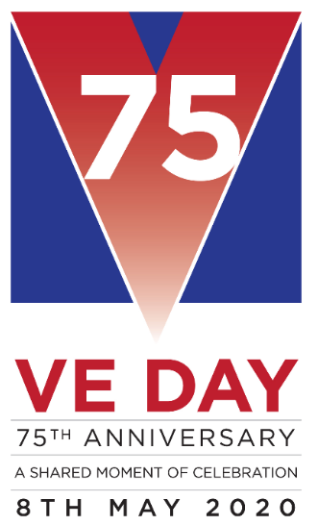  On Friday 8th May the UK will be celebrating the 75th anniversary of VE Day.  Use the PowerPoint on the class webpage to help you find out about VE day and how people celebrated the end of WWII.  Don’t forget the 2Dos on PurpleMash  You might want to choose to make something from our Wartime Recipe Booklet.  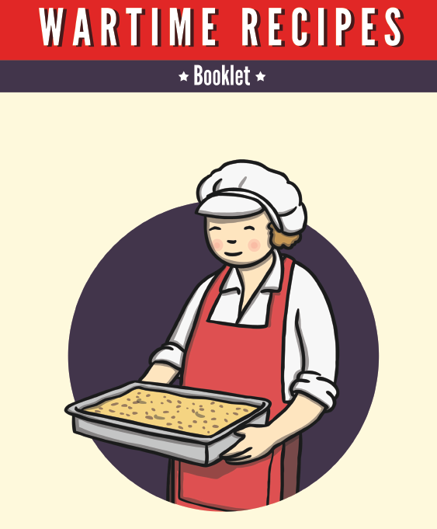  Don’t forget to send us picture to show how you are celebrating VE Day with your family at home.  Can you make decorations to celebrate VE day at home?
Robinhood Doubles

Check out this online game which helps you to practise your doubles.
www.ictgames.com/mobilePage/archeryDoubles/index.html
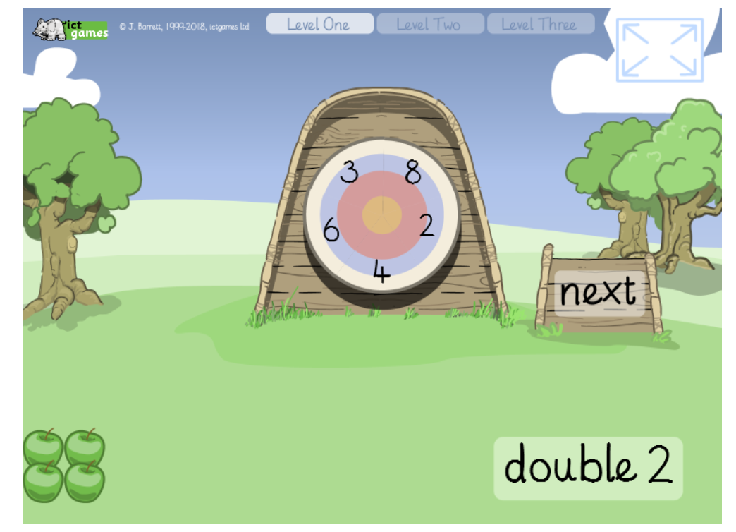
Problem Solving with Doubles

We have uploaded this home learning challenge to the class webpage.

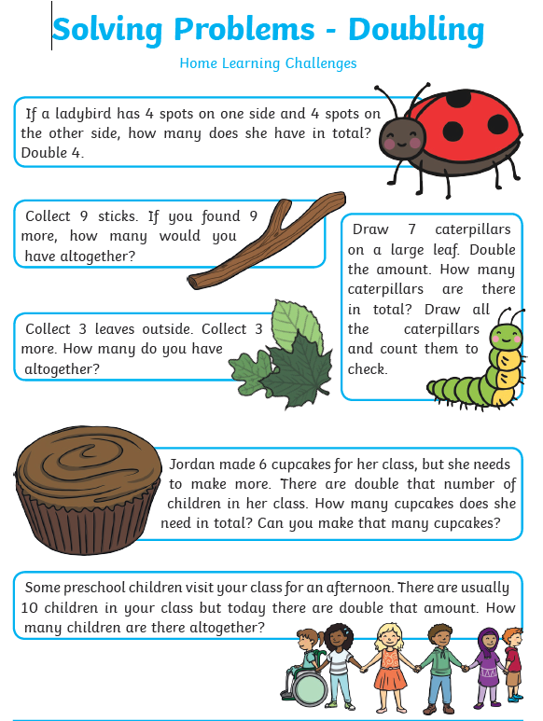
Practise letter formation:
https://www.doorwayonline.org.uk/activities/letterformation/

Remember to click free draw and you can either practise a random selection or your grown up might choose letters that they think you need extra practise with.
Fine Motor Activities
Developing finger strength can really help improve pencil grip and letter formation.
- Use cloths pegs to help hang out the washing.
- Use construction pieces, e.g. Lego
- Use a pair of tweezers/kitchen tongs to pick up small household objects

