Phonics | Handwriting/Tricky Words | Maths- 3D Shapes | Topic- Summer
Check out the DfE’s new daily online phonics lessons for parents:  https://www.youtube.com/channel/UCP_FbjYUP_UtldV2K_-niWw/  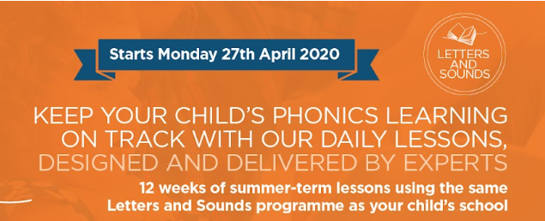  Remember your child will also benefit from regular practise of a range of Phase 2 and Phase 3 games on Phonics Play website:  Remember to practise segmenting and blending words when reading and spelling!  You might also find the KS1 Bitesize Phonics lessons and games useful.  ASTREA PROMISE ACTIVITY  To achieve the Astrea Promise Rainbow Award for FS2, we need to read a book in an unusual place. In April, we had planned to take the children to Conisbrough Castle for a special story telling session, however, you can tick of this activity by taking part in Mrs Mason’s reading challenge.  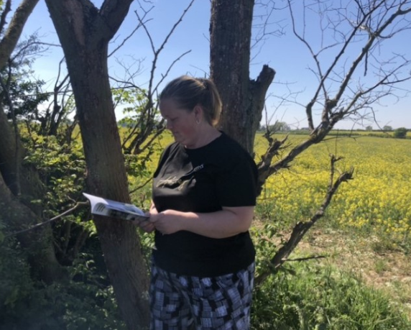  Please send us a photo of yourself reading in an unusual place.  Send your pictures to fs2obs@astreacastle.org | This week can you continue to find different ways to practise spelling the Phase 3 tricky words:  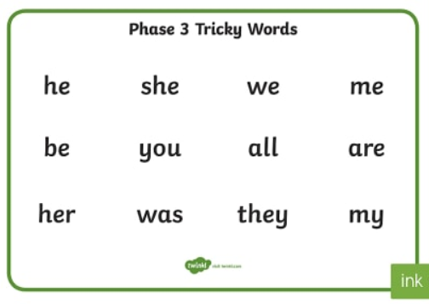  Can you write a sentence using the words above?  We have uploaded a Phase 3 Tricky Word Booklet and Letter Formation sheets on the class webpage, which you might find useful. | Mental Maths- practising counting in 10s up to 100 aloud.  3D Shapes  The aim of this week is for children to be able to name common 3D shapes below and be able to recognise 3D shapes in the environment.  It is also important to emphasise the difference between 2D shapes (flat) and 3D shapes (solid).  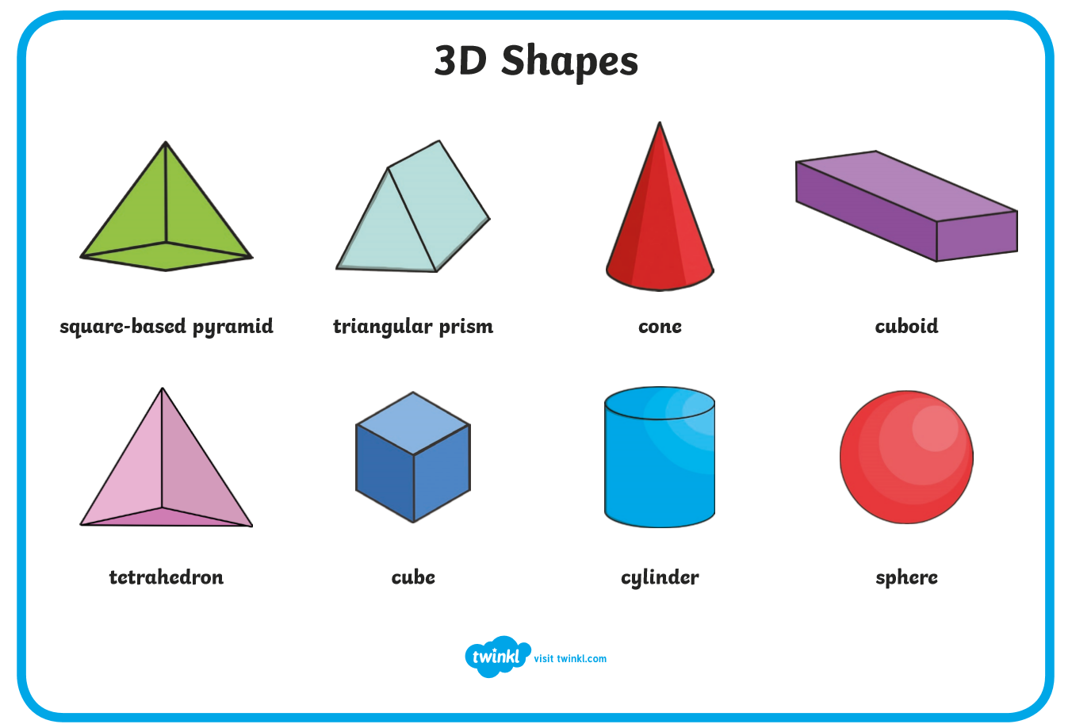  You might encourage children to begin to talk about properties of 3D shapes, however, please make sure you are using the correct vocabulary.  3D shapes have ‘faces’ not sides!  3D Shape Hunt  Use ‘Everyday 3D Shapes’ to introduce 3D shapes and encourage children to find real objects from around the house that are the same shape.  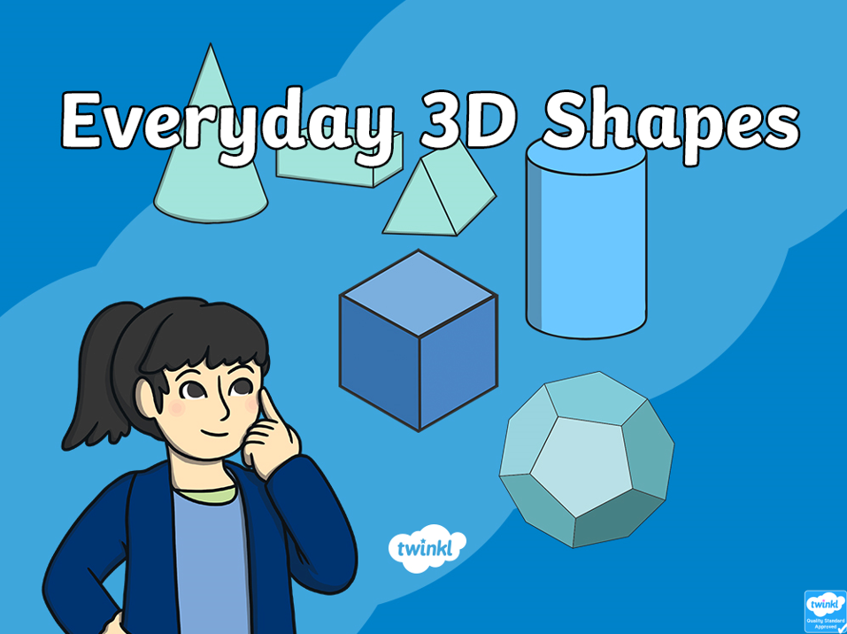  Don’t forget to send us pictures of your shape hunt. You might choose to sort objects out into piles of each shape too! Practise your counting skills by counting how many of each shape have you found?  3D Shape Booklet  We have uploaded a 3D Shape Booklet to the class webpage.  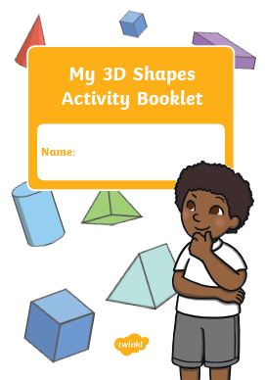 | As we are now in the final half of the Summer Term and we have been enjoying some glorious weather lately, this week we will be focusing on the season of Summer and Sun Safety.  Summer  Use the PPT ‘All about Summer’ or research online to find out facts about the season of Summer.  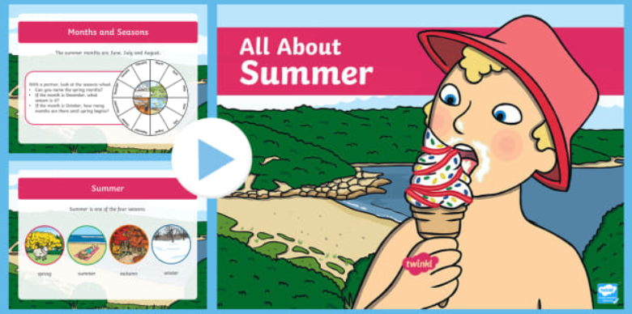  How is it different to Autumn, Winter and Spring?  Login in to PurpleMash and complete your Summer 2Dos.  Music & Dance  Listen to the ‘Four Seasons: Summer’ by Vivaldi. Can you perform summer actions to the music?  For example, building sandcastles, swimming, licking ice cream… etc.  https://www.bing.com/videos/search?q=vivaldi+summer&&view=detail&mid=A2500DBDF8BEBBBC874DA2500DBDF8BEBBBC874D&&FORM=VRDGAR  Sun Safe Superstars!  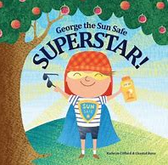  Watch the video link below and enjoy the story about ‘George the Sun Safe Superstar’:  https://www.bing.com/videos/search?q=sun+safe+super+hero&docid=608012406486401561&mid=0A4867150B4C053E8BE00A4867150B4C053E8BE0&view=detail&FORM=VIRE  Research ways that you can keep safe in the sun and create a poster with pictures and captions.
Practise letter formation:
https://www.doorwayonline.org.uk/activities/letterformation/
Remember to click free draw and you can either practise a random selection or your grown up might choose letters that they think you need extra practise with.
Gross Motor Activities
This week we would like to see the children practising their gross motor skills.

Ball Skills
Practising throwing and catching.

How many different ways can you pass the ball to someone else?
(Throwing, bouncing, kicking etc)
Our Astrea Promise Celebration Event, will take place in some form and at some point when we return to school. Therefore, it is essential that we continue to evidence how we are meeting the different elements of the Awards. Mrs Bradley will be collecting evidence for FS2 and tracking individual pupil progress towards their award.

In FS2, children having been working to achieve the Astrea Promise Rainbow Award.
Activity 1 | Activity 2 | Activity 3 | Activity 4 | Activity 5 | Activity 6 | Activity 7 | Activity 8 | Activity 9
Meet Everyday Heroes | Attend a Theatrical Performance | Go on Local Walk | Sing around a Campfire | Read a Story in an unusual place. | Visit a Farm | Observe a life cycle of a living thing | Teddy Bears Picnic | Explore different transport
We have met the school nurse and a War Veteran in the Autumn Term. | We have watched 2 Pantos around Christmas. We also got to watch KS2 Christmas Play. | Send us a picture of you going on a local walk as part of your daily exercise routine.  You need to send evidence in to school. | We are hoping to complete this one together when we return to school. | Send us a picture of you reading a story in an unusual place- where will you find to read?  You need to send evidence in to school. | Complete the PurpleMash 2Do about Farms to have this activity signed off.  You need to send evidence in to school. | We attempted to hatch living eggs in the Spring Term.  Some children have also sent evidence of them finding out about the life cycle of a frog! | THIS WEEK:  As it is unlikely that we will be able to bring in toys from home on our return to school, we are setting this as a home learning activity.  You need to send evidence in to school. | Activity suggestions coming soon!
Send evidence to FS2obs@astreacastle.org

