Spellings | Literacy | Maths | Astrea Promise Activities | Science
Play the assignment on Spelling Shed  Spellings to practice using speed spell or pyramid spelling  Careful  Playful  Thankful | Desert Island  Can you write an adventure story about being stranded on a desert island?  First create a plan of your story.  Think about who the characters in the story are and what is going to happen in in your story.  How do your characters get stranded on the island?  Is there a plane crash?  Is there a boat accident?  Maybe you are swimming with your friends and get caught in a current to the island?  Are there any animals on the island?  What do your character’s eat and drink?  What is the weather like?  How do your character’s get off the island?  Maybe they build a raft or send a message in the bottle. | Times tables rock stars.  Mymaths  You will have all received a login for ‘Mymaths’ and I can see that lots of you have already completed assignments on here which is great. I am going to set some more assignments for this week.  Number Facts and doubles 3  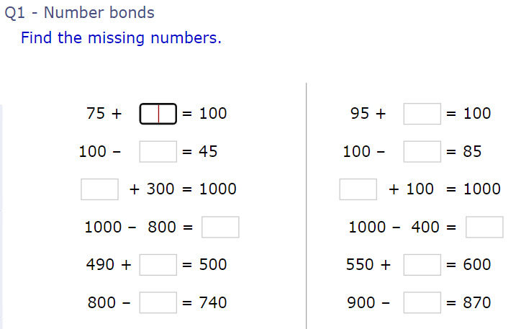  Counting on over 10 and 20.  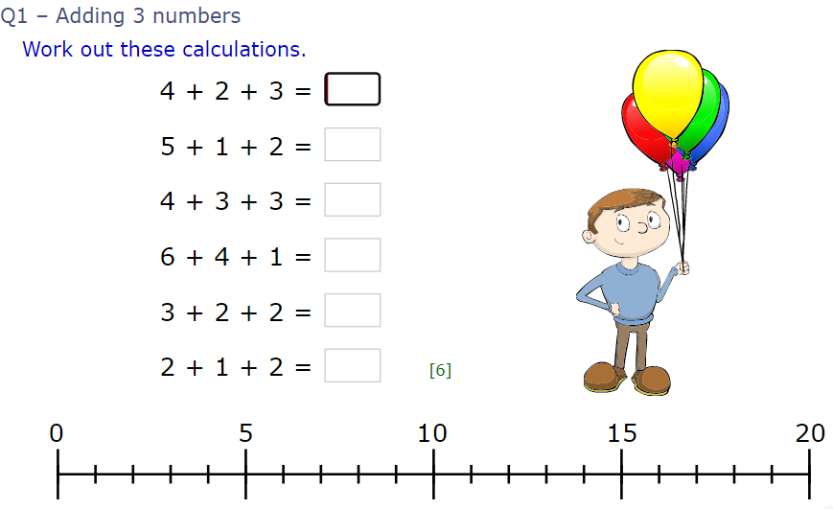  Sums crossing 10’s  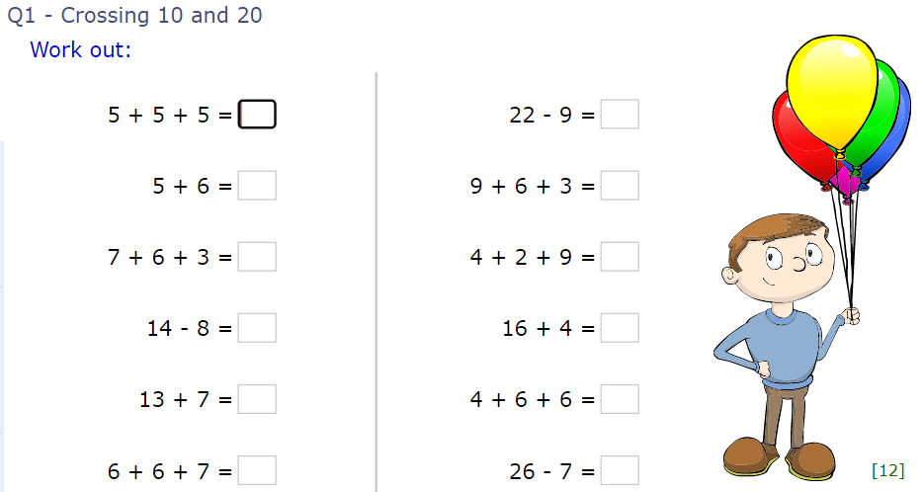  Adding and Taking Away  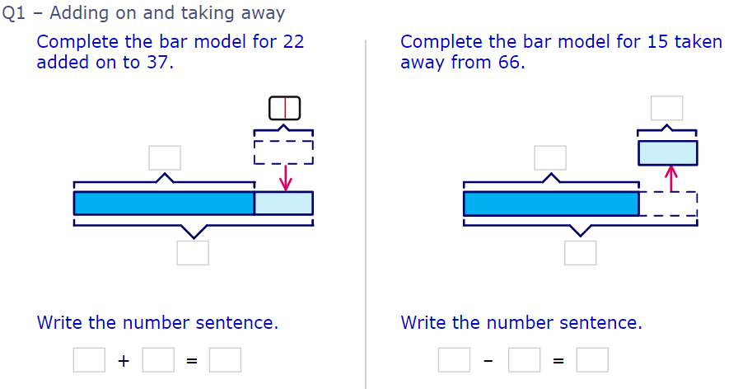 | Because we haven't had the chance to complete all our Astrea Promise challenges yet, I will be setting challenges for you to complete at home over the next few weeks. If you complete any challenges could you please send a photograph by either Facebook or email as evidence to achieve this element of the ‘Astrea Promise’. | Living things and their habitats.  Living, dead, never been alive.  Earlier in Year 2 we learnt about things that were living eg, plants, animals, and people. Things that were dead eg, leaves fallen from trees, dead plants and creatures and fruit and vegetables that have been harvested, wooden objects. Things that have never been alive eg. Things made of plastic, metal etc.  Can you do a search around your house to find objects that are living, dead or never been alive? You could record it in a table like this.  Living Dead Never been alive
Play the assignment on Spelling Shed  Spellings to practice using speed spell or pyramid spelling  Helpful Wonderful |  |  | Family Fun  This could be any activity of you having fun with your family. It could be baking, making something, playing in the garden, dancing and singing etc. If you could take some photographs I would love to see them.  I completed this challenge with my family by having a water fight in the garden!
Play the assignment on Spelling Shed  Spellings to practice using speed spell or pyramid spelling  Useless  Careless |  |  | Find Your Fail  Think of one thing that you wish you were better at. This could be handwriting, reading, playing football, drawing etc. Could you spend some time every day practicing this skill? Take a photograph or video of you at the beginning of your challenge and one at the end. I would love to see your challenges. | Local Habitats  How many different habitats do you have in your local area?  Could you make a list of them and any living things that you can find there?  Eg.  Pond  Tadpoles  Fish  Mallard ducks  Frogs............
Play the assignment on Spelling Shed  Spellings to practice using speed spell or pyramid spelling  Homeless  Spotless  Hopeless |  |  | Serve lunch to the community  Can you bake or cook something for other members of your family? Could you make everyone breakfast or lunch? Maybe you could host a dinner party and set the table nicely and prepare food for you family to enjoy. | Micro habitats  Remember Microhabitats are tiny habitats eg, a clump of grass, a tree, under a rock.  Can you find any microhabitats within your garden?  Can you take a picture or draw a picture of the different micro habitats?  What creatures can you find in the habitats?
Can you do a spelling test with a grown of this week’s spellings?  Careful  Playful  Thankful  Helpful Wonderful  Useless  Careless  Homeless  Spotless  Hopeless |  |  | Break a record  Can you research ‘Guinness World Records Kids’ On the website https://kids.guinnessworldrecords.com/ There is a very good section called ‘Do try this at home’ with great at home record breaking ideas. Choose a challenge to complete. You don’t need to break the world record but you could try to break your own personal record.  Some ideas are:  - Most balloons popped by sitting on them in 30 seconds.  - Most football touches in 30 seconds  - Most spoons balanced on the body  - Tallest toilet tower built  Take photographs of you completing your challenges I would love to see them.

