Phonics | Handwriting/Tricky Words | Maths- One Less, Take Away | Topic- Pirates
Check out the DfE’s new daily online phonics lessons for parents:  https://www.youtube.com/channel/UCP_FbjYUP_UtldV2K_-niWw/  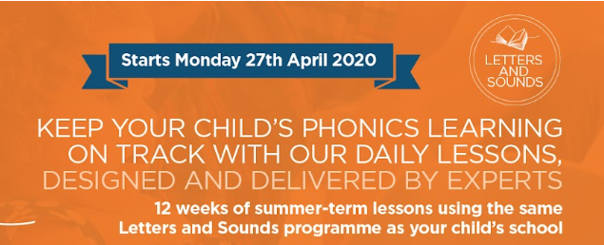  Remember your child will also benefit from regular practise of a range of Phase 2 and Phase 3 games on Phonics Play website:  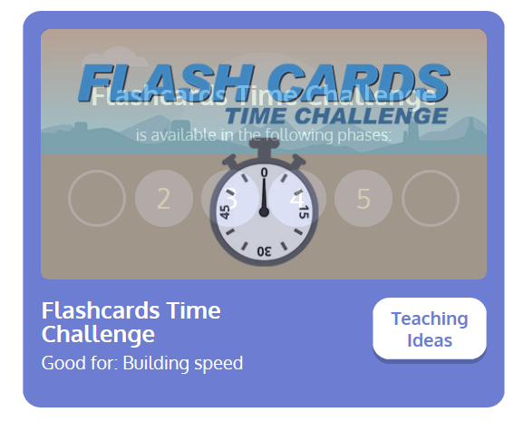  How many sounds can you recognise in one minute?  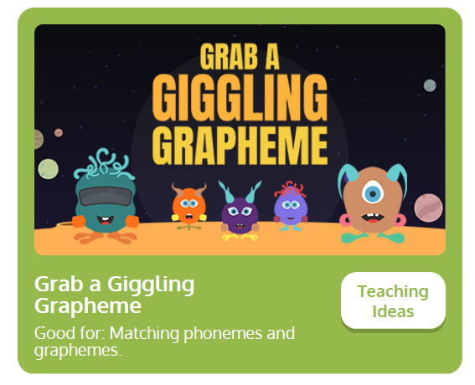  Listen to the aliens pronounce the Phase 3 graphemes- can you click on the correct digraph?  This week’s focus sounds are ‘oo’ and ‘ar’  Digraph- two letters that make up one sound, e.g. ‘oo’ in moon.  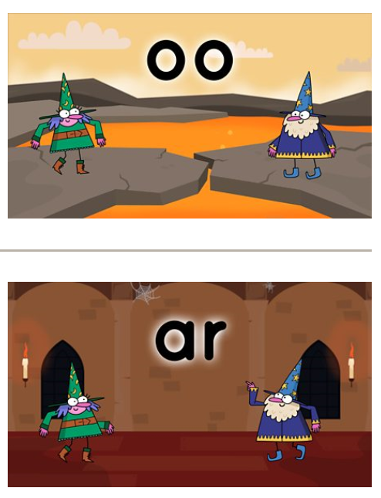  You might also find the KS1 Bitesize Phonics lessons and games useful.  https://www.bbc.co.uk/bitesize/topics/zvq9bdm/articles/zr6f6v4  ‘oo’ and ‘ar’ words  Practise reading and spelling phase 3 words:  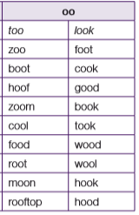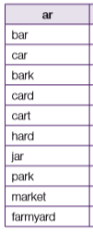 | Recap: continue to recap practise spelling the Phase 3 tricky words:  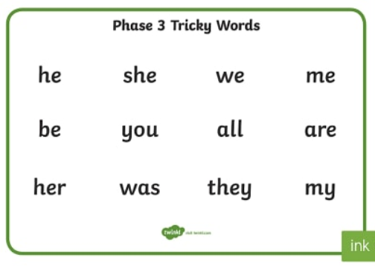  Play ‘Tricky Trucks’ on Phonics Play:  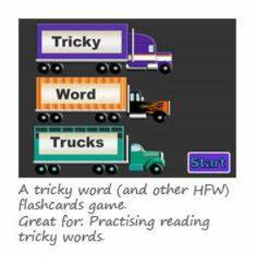 | Arithmetic  Practise counting back from 20 to zero.  One Less  Say a number between 20-1 to your child. Can they respond by telling you which number is one less/comes just before?  Subtraction  Give the children a set of up to 10 objects. Roll a dice. Take that number of objects away. How many are left?  8 – 3 = 5  Model writing a number sentence to show what you have done. Can the chidlren record their own number sentences.  Play a subtraction game online.  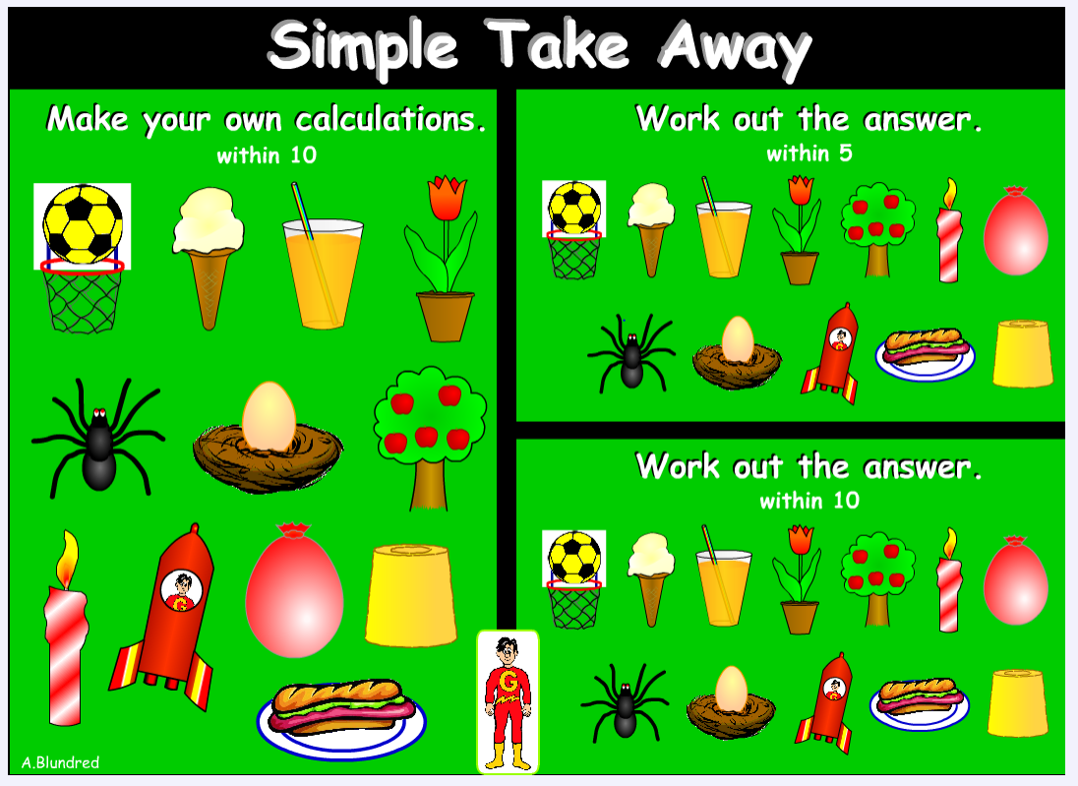  https://www.topmarks.co.uk/Flash.aspx?f=TakeAway  Counting Back  Choose a number between 6 and 20 and find it on the number line. Roll a dice to generate a number to take away. Model counting back by jumping from the start number.  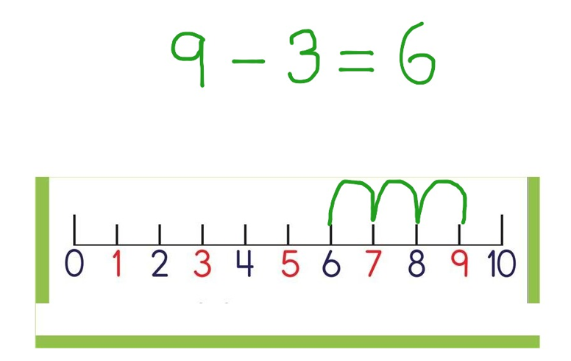  Remember not to count the start number and count the correct number of jumps to find the answer. | Ahoy there shipmates!  This week we will be looking at the theme of Pirates.  Talk to your child about what a pirate is. Pirates are not always kind. Write a list of ‘Top Tips’ to help them be kind.  Design your own Wanted Poster for a pirate. I wonder how much you will pay for the reward!  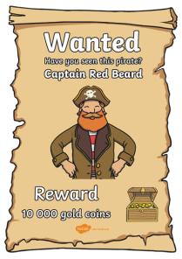  Look on YouTube and listen to a variety of Pirate themed audio books, such as Pirates Go To School or The Pirates Next Door. Which story did you like best?  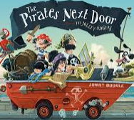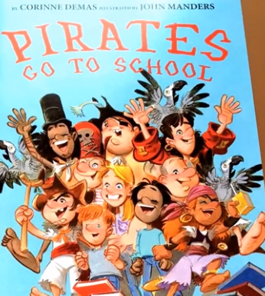  Why not dress up and pretend to be a pirate. Email pictures into us if you do, we’d love to see your costumes!  Use PurpleMash software to create a pirate or decorate your pirate ship.  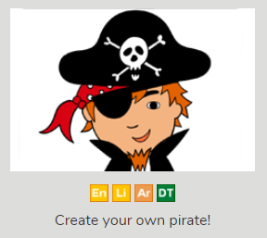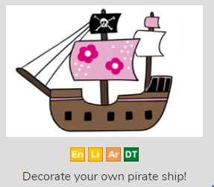  Pirate themed crafts –  Treasure Map - Stain a piece of white paper with a tea bag to make the paper look old, let it dry and draw your own ancient treasure map on it.  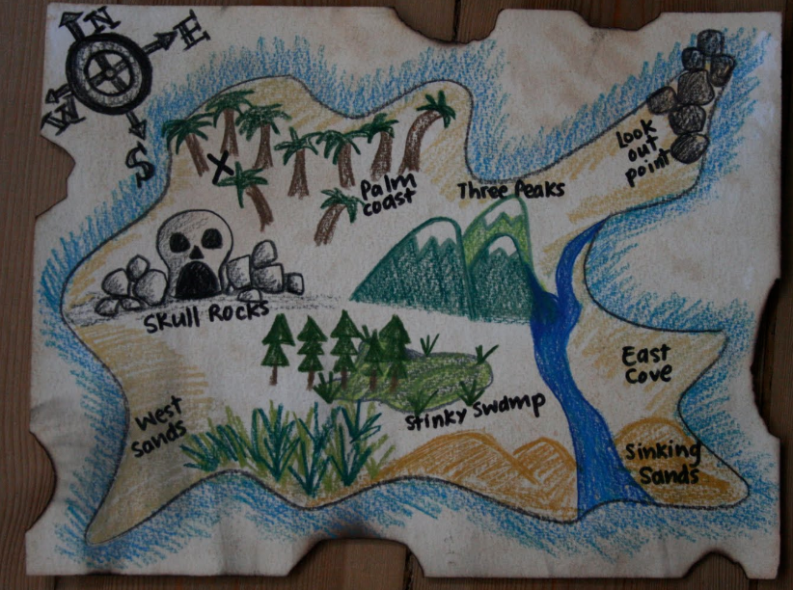  Pirate Accessories –  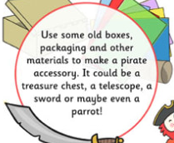
Practise letter formation:
https://www.doorwayonline.org.uk/activities/letterformation/
Remember to click free draw and you can either practise a random selection or your grown up might choose letters that they think you need extra practise with.
Gross Motor Activities
This week we would like to see the children practising their gross motor skills.

Imagine a pirate is making you walk the plank.

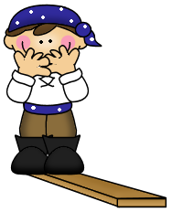
Children have to walk in a perfect straight line one foot exactly in front of the other with arms outstretched to the sides. You could make this activity more challenging by walking along benches or low walls.
Our Astrea Promise Celebration Event, will take place in some form and at some point when we return to school. Therefore, it is essential that we continue to evidence how we are meeting the different elements of the Awards. Mrs Bradley will be collecting evidence for FS2 and tracking individual pupil progress towards their award.

In FS2, children having been working to achieve the Astrea Promise Rainbow Award.
Activity 1 | Activity 2 | Activity 3 | Activity 4 | Activity 5 | Activity 6 | Activity 7 | Activity 8 | Activity 9
Meet Everyday Heroes | Attend a Theatrical Performance | Go on Local Walk | Sing around a Campfire | Read a Story in an unusual place. | Visit a Farm | Observe a life cycle of a living thing | Teddy Bears Picnic | Explore different transport
We have met the school nurse and a War Veteran in the Autumn Term. | We have watched 2 Pantos around Christmas. We also got to watch KS2 Christmas Play. | Send us a picture of you going on a local walk as part of your daily exercise routine.  You need to send evidence in to school. | THIS WEEK: In school we will be heading outdoors to sing around the camp fire. | Send us a picture of you reading a story in an unusual place- where will you find to read?  You need to send evidence in to school. | Complete the PurpleMash 2Do about Farms to have this activity signed off.  You need to send evidence in to school. | We attempted to hatch living eggs in the Spring Term.  Some children have also sent evidence of them finding out about the life cycle of a frog! | As it is unlikely that we will be able to bring in toys from home on our return to school, we are setting this as a home learning activity.  You need to send evidence in to school. | We conducted a traffic survey in June with the children in school.  You need to send evidence in to school.
Send evidence to FS2obs@astreacastle.org

