Phonics | Handwriting/Tricky Words | Maths- Counting | Topic- Transition
Check out the DfE’s new daily online phonics lessons for parents:  https://www.youtube.com/channel/UCP_FbjYUP_UtldV2K_-niWw/  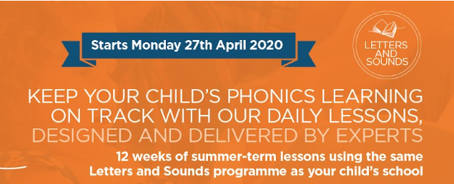  Remember your child will also benefit from regular practise of a range of Phase 2 and Phase 3 games on Phonics Play website:  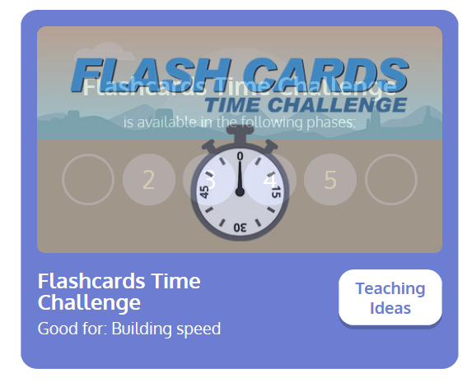  How many sounds can you recognise in one minute?  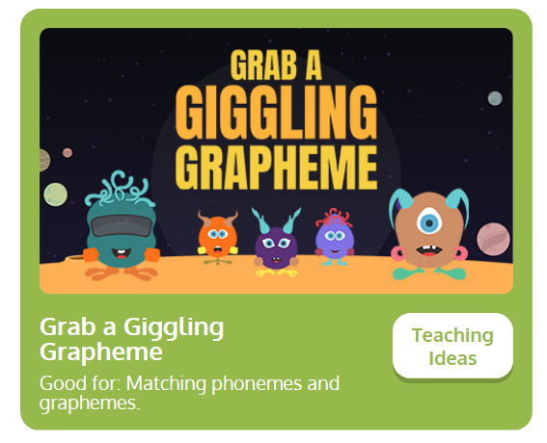  Listen to the aliens pronounce the Phase 3 graphemes- can you click on the correct digraph?  This week’s focus sounds are  ‘or’ and ‘ur’  Digraph- two letters that make up one sound, e.g. ‘ur’ in burn.  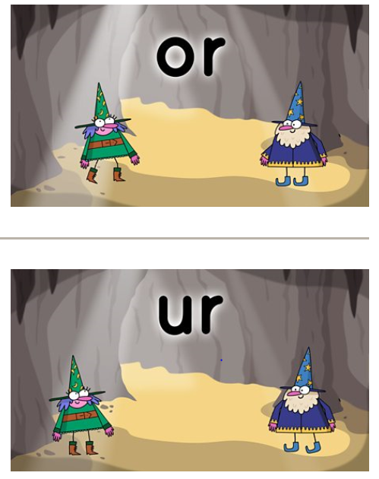  You might also find the KS1 Bitesize Phonics lessons and games useful.  https://www.bbc.co.uk/bitesize/topics/zvq9bdm/articles/zr6f6v4  ‘or’ and ‘ur’ words  Practise reading and spelling phase 3 words:  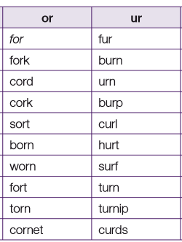 | Recap: continue to recap practise spelling the Phase 3 tricky words:  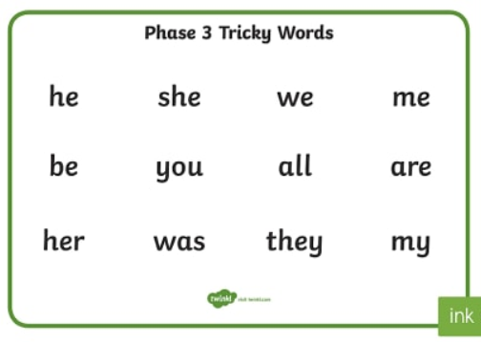  Play ‘Tricky Trucks’ on Phonics Play:  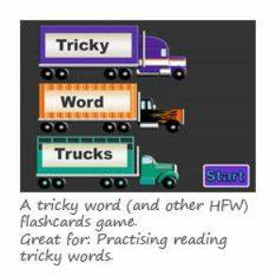 | Practise counting sets of objects up to 20. You could use real objects from around the house or print out our counting to 20 booklet below:  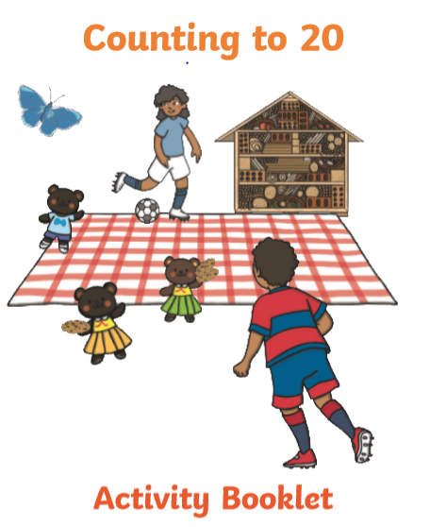  Practise ordering 0-20 forwards and backwards.  Can you make up your own games using numbers 0-20.  E.g. Close your eyes and your partner will hide a number. Can you work out which number is missing? Can you explain how you know?  “I know 6 is missing because 6 comes after 7.”  Counting in 10s!  Practise counting in 10s aloud from 10-100. Click on the image below to listen to the counting by 10s song.  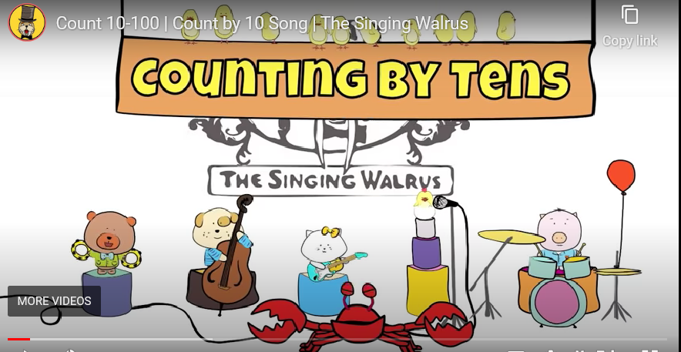  Write the tens numbers out on paper. Can you place them in order?  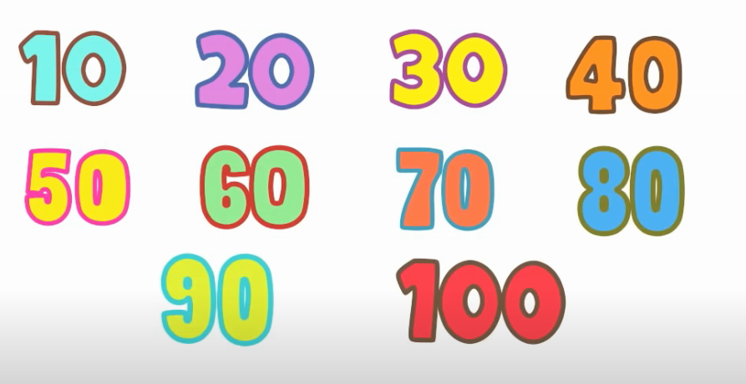 | 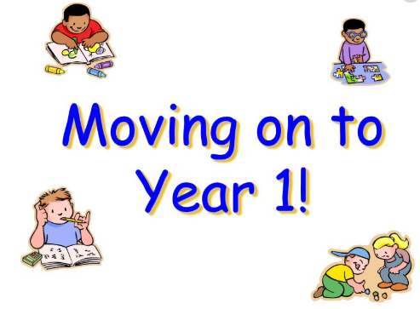 This week as it is the last week of FS2, we will be looking at the theme of Transition.  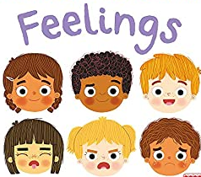 Discuss with your child their feelings about leaving FS2 and moving onto Year 1.  Why not send an email or a video clip in to us with questions that you want to ask Miss Gelder about Year One.  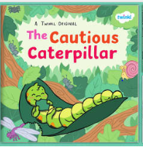  Read the story, and complete the activity ‘Spreading my Wings from Reception to Year 1’.  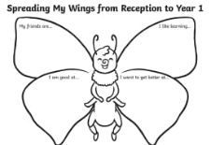  Use Purple Mash Software to make a poster which tells Miss Gelder all about you and create a self-portrait too.  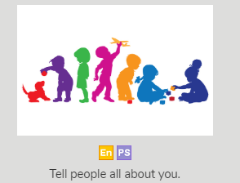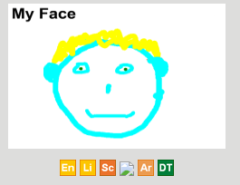  Think about your favourite memories of FS2. Draw a picture and write a sentence to match or complete the activity below.  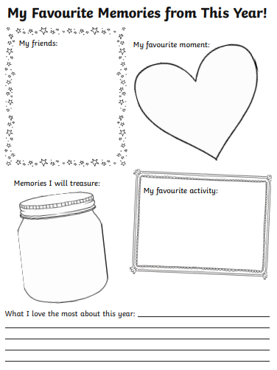  Create a Memory Jar of your time at Castle Academy so far.
Practise letter formation:
https://www.doorwayonline.org.uk/activities/letterformation/
Remember to click free draw and you can either practise a random selection or your grown up might choose letters that they think you need extra practise with.
Gross Motor Activities
This week we would like to learn some Ballet. Click on the image below and watch and copy the ballet movements.

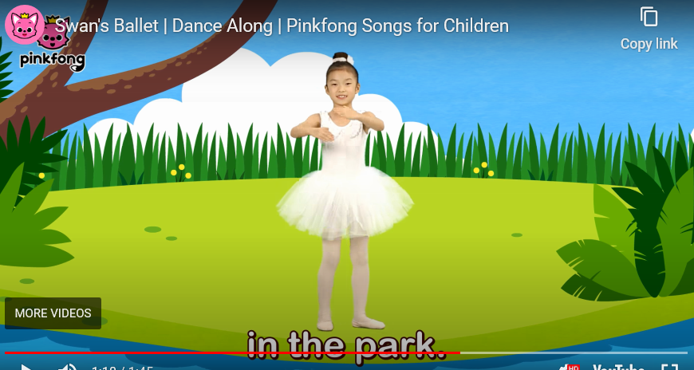

Ballet is great exercise for both boys and girls.

Our Astrea Promise Celebration Event, will take place in some form and at some point when we return to school. Therefore, it is essential that we continue to evidence how we are meeting the different elements of the Awards. Mrs Bradley will be collecting evidence for FS2 and tracking individual pupil progress towards their award.

In FS2, children having been working to achieve the Astrea Promise Rainbow Award.
Activity 1 | Activity 2 | Activity 3 | Activity 4 | Activity 5 | Activity 6 | Activity 7 | Activity 8 | Activity 9
Meet Everyday Heroes | Attend a Theatrical Performance | Go on Local Walk | Sing around a Campfire | Read a Story in an unusual place. | Visit a Farm | Observe a life cycle of a living thing | Teddy Bears Picnic | Explore different transport
We have met the school nurse and a War Veteran in the Autumn Term. | We have watched 2 Pantos around Christmas. We also got to watch KS2 Christmas Play. | Send us a picture of you going on a local walk as part of your daily exercise routine.  You need to send evidence in to school. | THIS WEEK: In school we will be heading outdoors to sing around the camp fire. | Send us a picture of you reading a story in an unusual place- where will you find to read?  You need to send evidence in to school. | Complete the PurpleMash 2Do about Farms to have this activity signed off.  You need to send evidence in to school. | We attempted to hatch living eggs in the Spring Term.  Some children have also sent evidence of them finding out about the life cycle of a frog! | As it is unlikely that we will be able to bring in toys from home on our return to school, we are setting this as a home learning activity.  You need to send evidence in to school. | We conducted a traffic survey in June with the children in school.  You need to send evidence in to school.
Send evidence to FS2obs@astreacastle.org

