Art | Artist
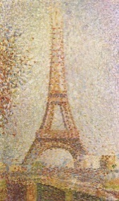 | Georges Seurat, The Eiffel Tower (1889)
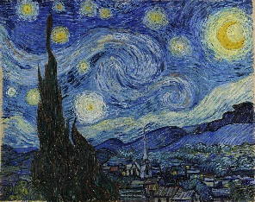 | Van Gogh, The Starry Night (1889)
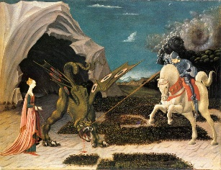 | Paolo Uccello, St George and the Dragon (1470)
Knowledge Organiser- Style in Art/Narrative Art (Art - Year One)

Key Vocabulary | Definition
style | How a piece of art looks
technique | The way in which an artist creates their work
pointillism | Art created using lots of dots
brushstroke | The mark made by a paintbrush
narrative | A piece of art that tells a story with colour and lines, instead of words
character | A person or animal in a piece of narrative art
setting | The place where a story takes place

